Hach JOB Cal® Basic

Quick Start Guide

OVERVIEW
Hach JOB Cal® is a computerized maintenance management program that assists you in your maintenance operations. There are two products in the JOB Cal family. Hach JOB Cal Basic which is the focus of this tutorial and provides the basic functionality of managing your calendar and work orders. Hach JOB Cal Plus adds inventory, purchasing, vendor and labor tracking; while integrating equipment drawings, pictures and instructions.

The calendar is the heart of the JOB Cal system. It displays all the pending, overdue, and completed work for a sliding 56-week period. The status of all work orders can be obtained at a glance with the interactive color coding. Jobs can easily be closed, rescheduled, deleted, skipped, and created using the calendar.

Key terms to know:

- Equipment is what you maintain – for example: pump, instrument, or vehicle.
- Task is a function to be performed - for example, “Perform Calibration” would be a task.
- Work Order and a Job are the same thing - work to be done on a specific piece of equipment for a specific date.

First, you enter your equipment in Job Cal. Next you create your schedule by creating tasks and assigning pieces of equipment to the tasks. For example, you could assign a truck and a car to the task “Change Oil”. When you assign equipment to a task, you set up a schedule of when you want the task performed on that equipment. For example, the truck could be scheduled every 5000 miles and the car could be scheduled every 90 days. As you see the frequency of the task can be scheduled by time or metered values.
Once you enter your equipment and tasks; the system automatically generates work orders and displays them on the calendar. Using the calendar, work orders can be printed, closed (completed), rescheduled, modified, skipped, etc… The closed work order information is placed in a history file and can be accessed at any time. You can also produce reports from this data.

Hach JOB Cal Basic Tutorial
The following instructions will take you through the basic steps of entering equipment, entering a task, printing and closing a Work Order. Then you will be ready to set up your database.

If you need help getting started please contact us at 1 800 677 0067 or at imsupport@hach.com

STEP 1: Install Hach JOB Cal Basic
This step will install a single user. If you require a network setup please refer to the manual Chapter 1 or call support.
- Close any programs currently running.
- Place the JOB Cal CD into your CDROM (or DVD) drive.
- Setup should begin immediately (within 30 seconds), or choose [Start], [Run], type “D:Setup.exe” where D is your CDROM drive, and click OK.
- Enter your serial # located on the back of the JOB Cal CD case. Click OK.

- Follow the instructions on the screen, when the installation program displays the following box, click OK.
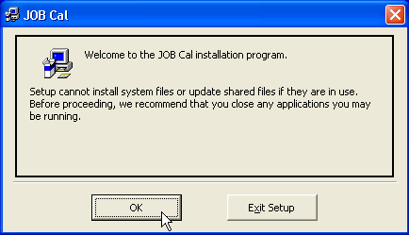

- The following screen will be displayed. Click the Install button to continue.
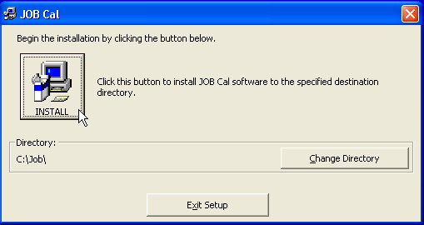

- Follow the instructions on the screen to complete the installation.

Two sample databases are created when you install the program, JobPlus.mdb and Tutor.mdb. Tutor.mdb contains some example data and will be used for this exercise; JobPlus.mdb doesn’t contain any data and can be used as your production database.

STEP 2: Start Hach JOB Cal
- Click on Start, Programs, OPS Systems, JOB

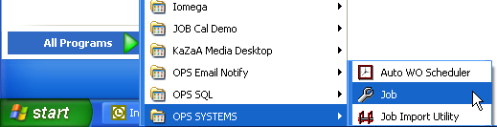

- Choose the Tutorial database from the list and click OK

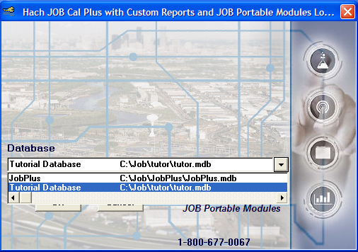

STEP 3: Enter Equipment
Equipment is any item (pumps, valves, vehicles, buildings, pipe lateral, anything) you want to track. Each piece of equipment needs a unique set of numbers and/or letters to identify it. If you do not have an existing equipment numbering scheme use simple abbreviations.

Using the Tutorial database, enter a piece of equipment.
- Click the Equipment Entry button 

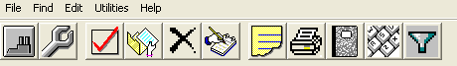

- Click the Add New button

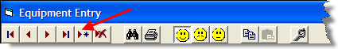

- Fill in the form with the following:
  - Equipment #: = 10-RP2
  - Description: = RAS Pump #2
  - Equip. Type: = Pump
  - Click Save & Close button

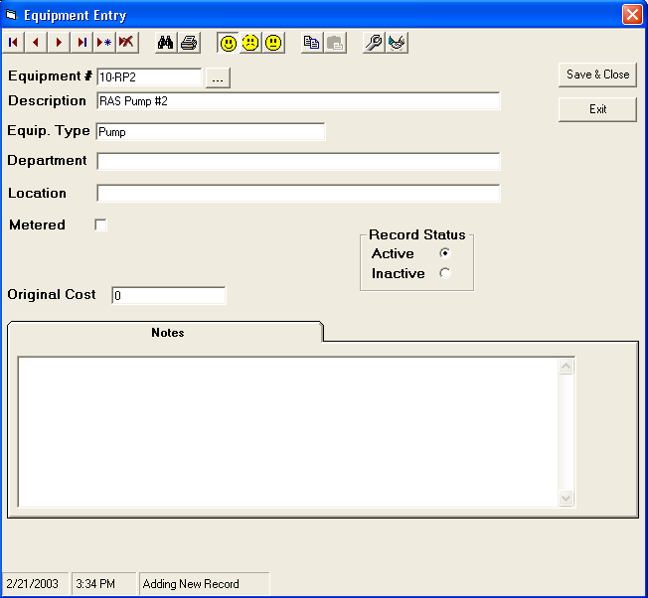

STEP 4: Enter Tasks
Tasks define the repetitive maintenance to be performed. For example, “Change Oil” in a car every three months is a task. The task records are used to build the JOB Calendar.

Using the Tutorial database, enter a task.
- Click the Task Entry Button 
- Click on the Add New button
- Fill in the form with the following:
  - Work Description: = Lube Pump
  - Est. Labor Hours: = 1
  - Instructions: = Grease 3 Fittings
- Add Equipment to the Task. Click on the Add Equipment button.

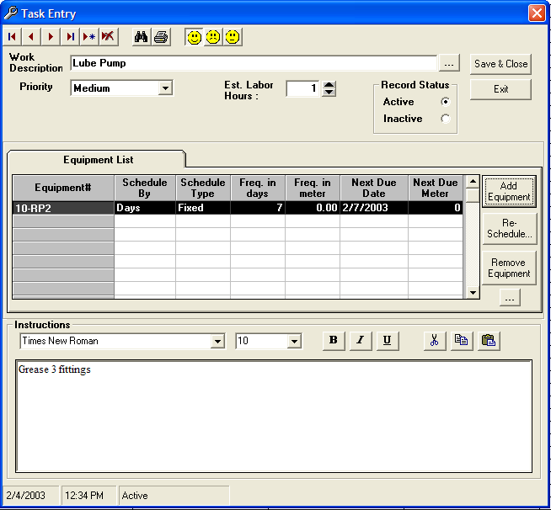
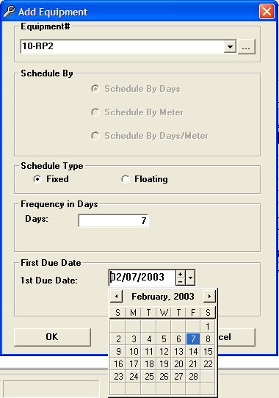
- Complete the Form
  - Select the RAS Pump #2 from the drop down list.
  - Schedule by: = floating
  - Frequency in Days: = 7
  - First Due Date: = (choose 3 days from today’s date)
  - Click OK.
The equipment is now added to the Task.

- Click the Save & Close button and the Work Order will be added to the calendar.

- Find the JOB you just created. It is an aqua color.

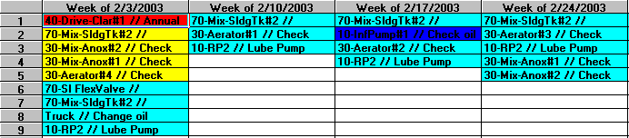

STEP 5: Using the Calendar
The Calendar displays scheduled work, completed work, overdue work, and skipped work for a sliding 56-week period (calendar shows the last 4 weeks of work complete, the current week, and 51 weeks into the future). Jobs can be closed, rescheduled, deleted, and created using the calendar. To use the calendar, click on a job (cell) to make it current and then perform an action on the job (close, move, etc.). The current jobs' detail is displayed at the bottom of the screen. As you move around in the interactive calendar, the detail will display information about the current job. The background color of a cell indicates the current status of the Job.

To be done
Up to 4 weeks overdue.
Greater than 4 weeks overdue.
Job skipped. When a job is skipped it is moved to the history table.
Completed (closed).
Estimated job based on meter readings and the date due is estimated.
Date/Meter job scheduled by the date or meter reading (whichever comes first).

Entering Job Data
To enter work information for a job, double click on the specific job on the calendar.

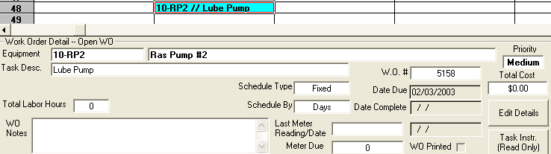

STEP 6: Printing Work Orders
- Click on an open Job you want printed (a closed Work Order / Job cannot be printed).
- Click the Print button. 

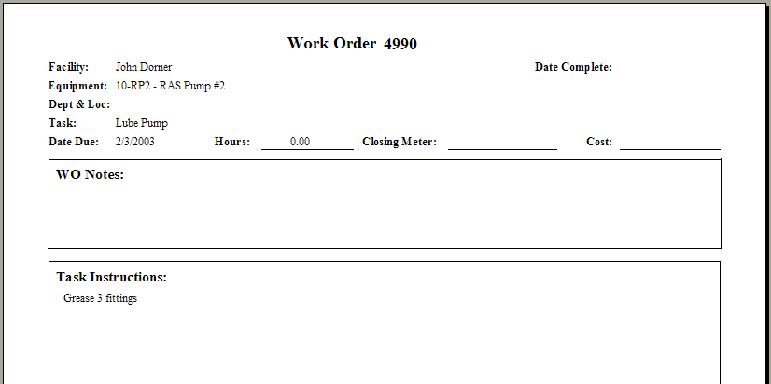

STEP 7: Closing a Job
After work on a job is complete, information about the job is entered (hours worked, etc...) and the job is put in history. To close a work order:

- Double-click on the Job/cell
- Enter Hours worked
- Enter the Date Complete
- Click Close Work Order button.

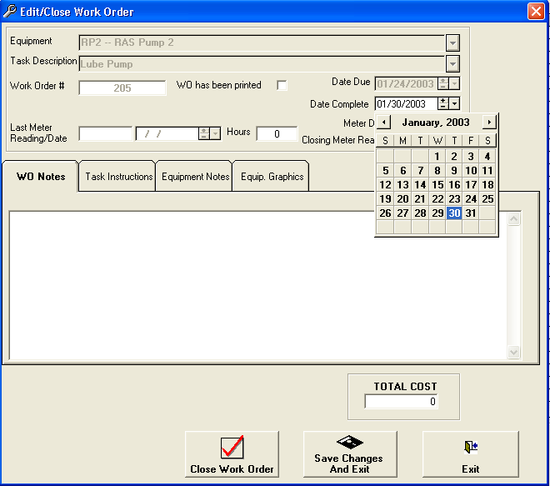

STEP 8: Reports

JOB Cal Basic allows you to print a number of reports. All reports are available from the report form.

- Click the Report button 
- Double click on the specific report you would like to view

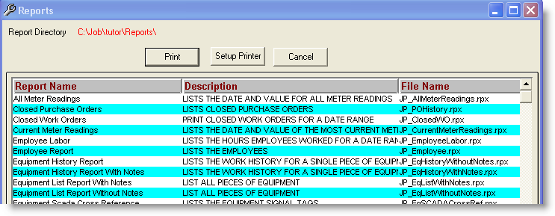

- Fill in the report criteria and press the OK button

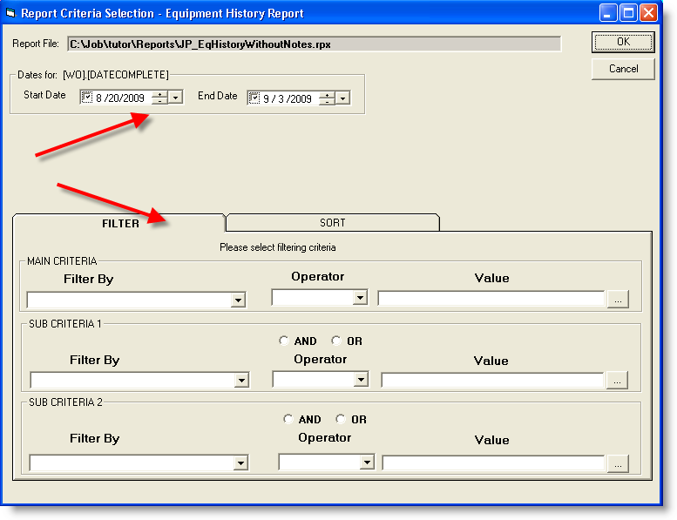

You now know the basics of JOB Cal. The next task is to start your database.

STEP 9: Create your own database
- In the Utilities menu select Database Setup.

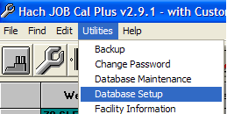

- Click on the Create New Database button.

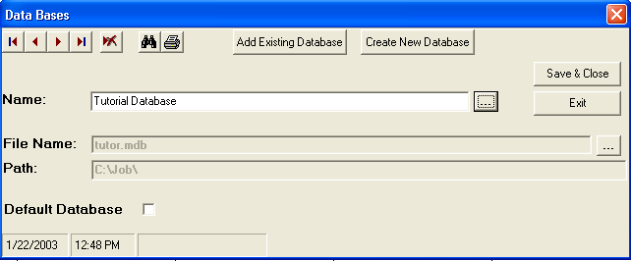

- Type in the name of your new database and select the location of where you want to store your database. (The easiest name to use is the name or initials of your facility). Click OK.
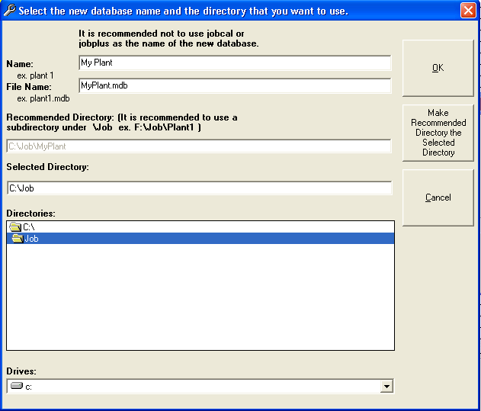

- You’ll see the Databases window again. Click the Save & Close button.

STEP 10: Enter Your Facility Information
- Select Utilities, Facility Information to open the Facility Information Window. Complete the form.
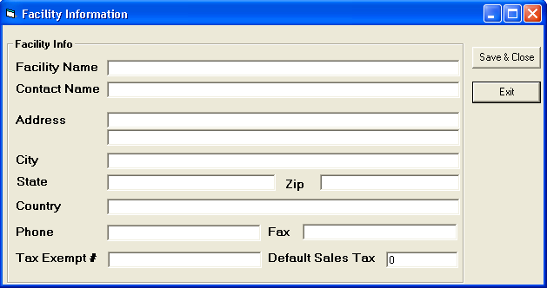

- Click Save & Close.

STEP 11: Log on to your database
- Go to the File menu, choose Open Database.
- At the log on screen select your database from the list and click OK.

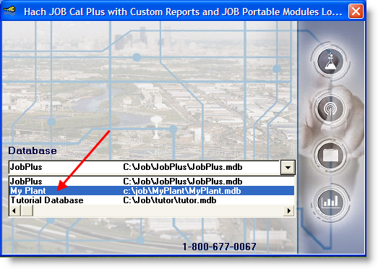

Enter your Equipment, then enter your tasks and JOB Cal will populate your calendar.

Job Cal Basic contains many more features and functions that are not covered in this basic tutorial. You will want to know more about fixed and floating schedules, metered equipment and reports. You can find more information in several places.

1. The online help. Click the Help menu and select Contents, or press the F1 key at any time to open the online help.

2. The user manuals which are supplied when you purchase Hach JOB Cal and are also included as Word documents on the Hach JOB Cal CD.

3. Contact Hach! For support call our toll free line 800-677-0067 or email us iimsupport@hach.com. For all other types of questions contact us at iimsales@hach.com.

